DATA SCIENCE WITH PYTHON INTERNSHIP
WEEK 1 TASK

Data Acquisition, Cleaning and Preprocessing
A documented workflow for preparing the Breast Cancer Wisconsin (Diagnostic) dataset for analysis

Submitted by | SIVASHANKARI S
Programme | Data Science with Python - Internship
Task | Week 1 Task
Dataset | Breast Cancer Wisconsin (Diagnostic) - UCI Machine Learning Repository
Tools | Python 3, Pandas, NumPy, Matplotlib, Seaborn, Scikit-learn
Date | 20 October 2026

Table of Contents
1. Introduction and Objectives
2. Data Collection Method
3. Environment and Libraries
4. Initial Data Exploration
5. Identifying Data Quality Problems
6. Fixing Data Types, Labels and Duplicates
7. Handling Erroneous Entries
8. Handling Missing Values
9. Outlier Analysis
10. Transformation and Feature Preparation
11. Validation of the Cleaned Dataset
12. Challenges Faced and How They Were Overcome
13. Impact of Preprocessing on Subsequent Analyses
14. Conclusion
15. References

1. Introduction and Objectives
Real-world data is rarely ready for analysis. It arrives with missing cells, inconsistent spellings, duplicated records, impossible measurements and extreme values whose meaning is not obvious. Any statistical summary, chart or machine-learning model built directly on such data inherits those flaws. The purpose of this report is to document, step by step, how a publicly available dataset was acquired, inspected, cleaned and preprocessed with Python so that it is trustworthy for later analysis.
The work follows the objectives of the Week 1 task:
- Acquire a public dataset from a reliable source and explain the collection method.
- Explore the structure and quality of the data before changing anything.
- Identify and treat missing values, inconsistencies, erroneous entries and outliers.
- Explain the rationale for every decision and show the Python code that implements it.
- Discuss how the preprocessing choices influence later analyses.
Every code block in this report was executed, and every console screenshot and figure was generated by that code. Nothing has been typed in by hand.

2. Data Collection Method

2.1 Source of the data
The dataset is the Breast Cancer Wisconsin (Diagnostic) dataset created by Dr. William H. Wolberg, W. Nick Street and Olvi L. Mangasarian at the University of Wisconsin and published through the UCI Machine Learning Repository, a widely trusted academic source. It is also distributed with the scikit-learn library, which is how it was loaded here with the function load_breast_cancer. This route needs no manual download and guarantees that anybody can reproduce the exact starting point.
Each of the 569 rows describes one breast mass. The features were computed from a digitised image of a fine needle aspirate (FNA) and describe the characteristics of the cell nuclei visible in the image. The label records whether the mass was diagnosed as malignant (212 cases) or benign (357 cases).

2.2 Why this dataset was selected
- Reliable provenance: published by the original researchers and cited in hundreds of papers.
- Real-world meaning: the variables are physical measurements, so impossible values (for example a negative texture) can be recognised using domain knowledge.
- Enough richness: 30 numeric features and a binary diagnosis allow every cleaning technique asked for in the task to be demonstrated.
- Reuse: the cleaned output can be used directly in the supervised learning task of Week 4.

2.3 Description of the variables
Ten basic measurements were computed for every nucleus. For each of them the mean, the standard error and the worst (largest) value in the image are stored, giving 10 x 3 = 30 features.
Table 1: The ten measurements recorded for each nucleus
Measurement | Meaning
Radius | Mean distance from the centre to points on the perimeter
Texture | Standard deviation of grey-scale values
Perimeter and Area | Size of the nucleus boundary and its enclosed region
Smoothness | Local variation in radius lengths
Compactness | Perimeter squared divided by area, minus 1
Concavity, Concave points | Severity and number of concave portions of the contour
Symmetry | Symmetry of the nucleus shape
Fractal dimension | Coastline approximation of the contour

2.4 An important note on the data quality exercise
The original UCI file is already clean: it has no missing values, no duplicates and no coding errors. A cleaning report on a perfectly clean file would have nothing to demonstrate. To practise the task honestly, a copy of the dataset was deliberately corrupted with a controlled set of realistic defects, using a fixed random seed. The untouched original was kept as ground truth. This has a useful side effect: because the true values are known, the quality of each cleaning decision can be measured objectively rather than assumed.
The defects injected into the working copy were:
Table 2: Controlled defects injected into the working copy
Defect | Amount | Real-world analogue
Missing values | 4% of rows in 8 columns | Sensor failure, skipped form fields
Impossible negative values | 6 in mean texture | Sign error during data entry
Decimal-place errors | 5 in mean area (x 10) | Misplaced decimal point
Placeholder text | 4 cells containing '?' | Legacy export conventions
Inconsistent labels | About 15% of diagnosis cells | Different data-entry staff
Duplicate records | 12 repeated rows | Double submission or merge errors

3. Environment and Libraries
The analysis uses Python 3 with Pandas for data handling, NumPy for numerical work, Matplotlib and Seaborn for visualisation, and Scikit-learn for imputation, scaling and a final model check. A global random seed makes the whole notebook reproducible.
Code 1: Importing libraries and setting the random seed
import os, numpy as np, pandas as pd
import matplotlib.pyplot as plt, seaborn as sns
from sklearn.datasets import load_breast_cancer
from sklearn.preprocessing import StandardScaler
from sklearn.impute import KNNImputer, SimpleImputer
from sklearn.linear_model import LogisticRegression
from sklearn.model_selection import cross_val_score, StratifiedKFold
from sklearn.pipeline import make_pipeline

FIG = "figs"
os.makedirs(FIG, exist_ok=True)
os.makedirs("out", exist_ok=True)
sns.set_theme(style="whitegrid", font="DejaVu Sans")
RNG = np.random.default_rng(42)

3.1 Loading the data
Code 2: Loading the dataset and keeping a clean reference copy
bc = load_breast_cancer(as_frame=True)
original = bc.frame.copy() # ground truth (clean) copy
print("Shape:", original.shape)
print("Target meaning:", {0: "malignant", 1: "benign"})
print(original.iloc[:5, [0, 1, 2, 3, 30]])

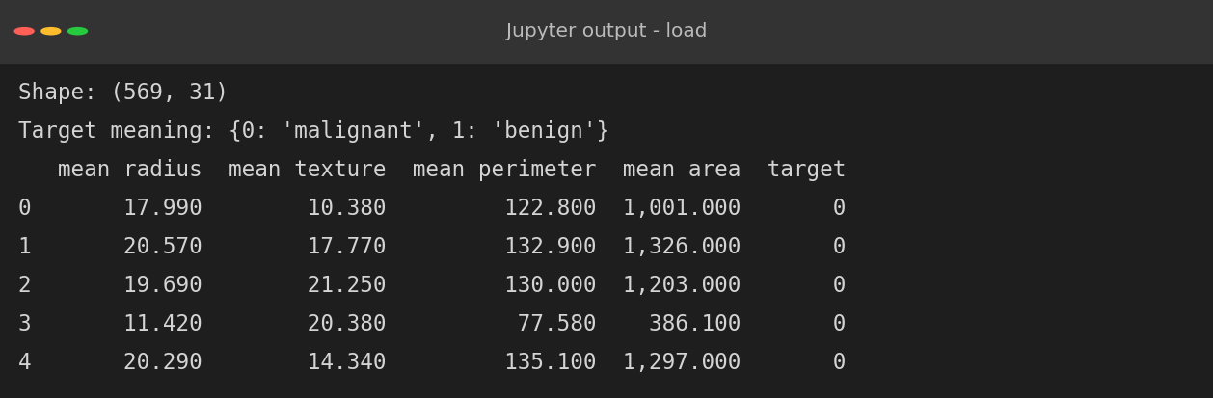
Figure 1: Shape and first rows of the original data
The original has 569 rows and 31 columns (30 features plus the target). A copy named original is kept untouched so that cleaned values can be compared with the truth at the end.
Code 3: Creating the raw working copy with controlled defects
raw = original.copy()
cols = ["mean radius", "mean texture", "mean perimeter", "mean smoothness",
"mean compactness", "mean concavity", "worst radius", "worst area"]
log = {}
for c in cols: # 1. missing values
idx = RNG.choice(raw.index, size=int(0.04 * len(raw)), replace=False)
raw.loc[idx, c] = np.nan
log[c] = len(idx)
bad = RNG.choice(raw.index, 6, replace=False) # 2. impossible negatives
raw.loc[bad, "mean texture"] = -raw.loc[bad, "mean texture"]
big = RNG.choice(raw.index, 5, replace=False) # 3. decimal-place errors
raw.loc[big, "mean area"] = raw.loc[big, "mean area"] * 10
raw["mean fractal dimension"] = raw["mean fractal dimension"].astype(object)
raw.loc[RNG.choice(raw.index, 4, replace=False),
"mean fractal dimension"] = "?" # 4. placeholder text
labels = raw["target"].map({0: "malignant", 1: "benign"})
noisy = {"malignant": ["Malignant", "M", "malignant ", "MALIGNANT"],
"benign": ["Benign", "B", " benign", "BENIGN"]}
raw["diagnosis"] = [RNG.choice(noisy[l]) if RNG.random() < 0.15 else l
for l in labels] # 5. inconsistent labels
raw = raw.drop(columns="target")
raw = pd.concat([raw, raw.sample(12, random_state=1)]) # 6. duplicates
raw = raw.sample(frac=1, random_state=7).reset_index(drop=True)
raw.to_csv("out/week1_raw_dataset.csv", index=False)
print("Injected defects:", {"missing/col": 23, "negatives": 6,
"area x10": 5, "'?' tokens": 4, "duplicates": 12})
print("Raw dataset shape:", raw.shape)

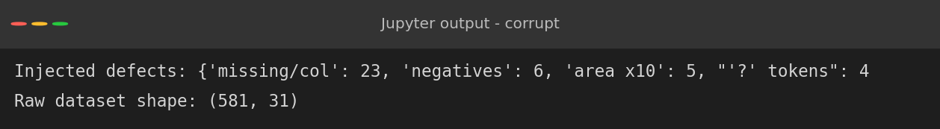
Figure 2: Summary of defects injected and size of the raw dataset
The raw working copy now has 581 rows (569 plus 12 duplicates) and is saved as week1_raw_dataset.csv. From this point on the code treats it exactly as if it had been received from an outside source.

4. Initial Data Exploration
Before changing anything, the structure and quality of the data are examined. The aim is to build a list of problems, not to fix them yet.
Code 4: Structure, data types, duplicates and label values
print(raw.shape)
print(raw.dtypes.value_counts())
print("\nObject columns:", list(raw.select_dtypes(exclude="number").columns))
print("Duplicate rows :", raw.duplicated().sum())
print("Total missing :", int(raw.isna().sum().sum()))
print("\nDiagnosis labels:")
print(raw["diagnosis"].value_counts().to_string())

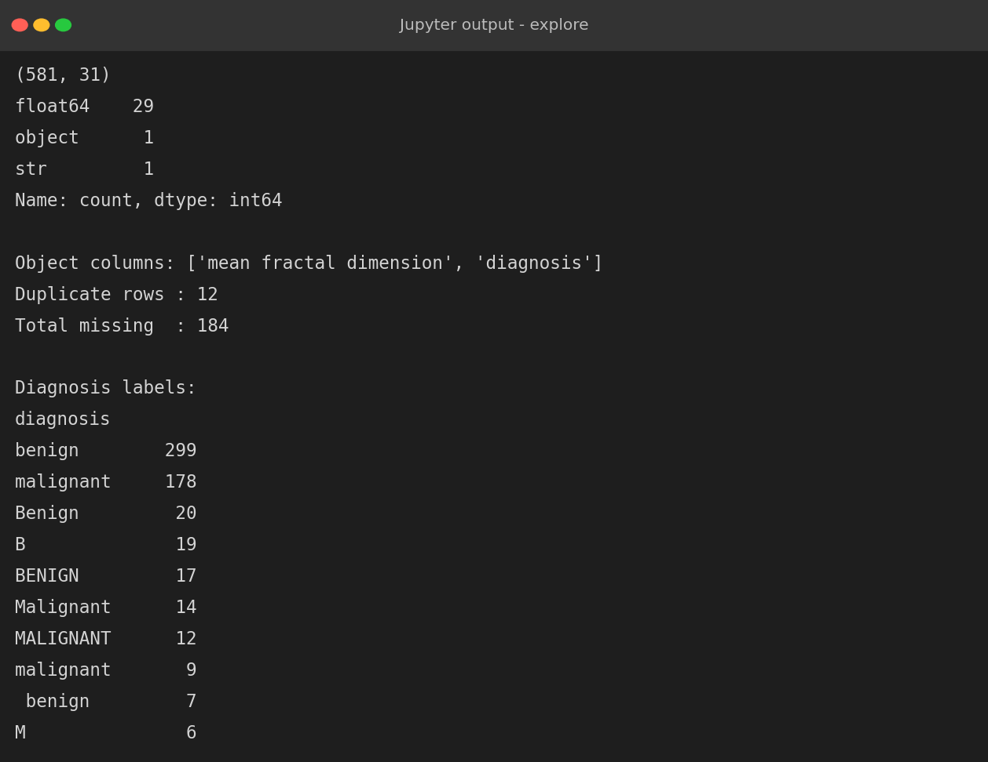
Figure 3: Structural overview of the raw dataset
Four problems are visible immediately:
- Wrong data types. One feature that should be numeric (mean fractal dimension) is stored as text, and the diagnosis column is text with many spellings.
- Inconsistent labels. The same two classes appear in many forms such as 'benign', 'Benign', 'B', 'BENIGN' and ' benign' with a leading space. Counting them as they stand would suggest ten classes instead of two.
- Duplicates. 12 rows are exact copies of other rows.
- Missing data. 184 cells are empty.
Code 5: Descriptive statistics of four key features
num = raw.drop(columns=["diagnosis", "mean fractal dimension"])
print(num[["mean radius", "mean texture", "mean perimeter",
"mean area"]].describe().round(2))

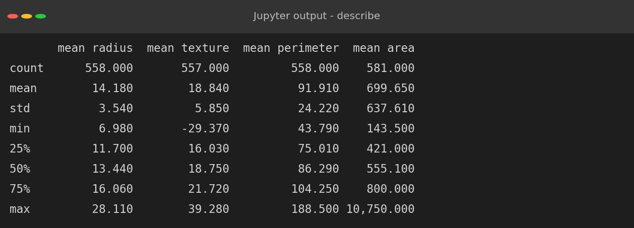
Figure 4: Summary statistics showing impossible values
The summary statistics expose two further problems. The minimum of mean texture is -29.37 which is physically impossible because texture is a standard deviation of grey levels. The maximum of mean area is 10,750 while the 75th percentile is only 800, a gap far too large to be natural.

5. Identifying Data Quality Problems

5.1 Missing values
Code 6: Counting and visualising missing values
miss = raw.isna().sum()
miss = miss[miss > 0].sort_values(ascending=False)
print(pd.DataFrame({"missing": miss, "percent": (miss / len(raw) * 100)}))
fig, ax = plt.subplots(1, 2, figsize=(12, 4.6))
sns.heatmap(raw.isna().iloc[:120, :12], cbar=False, cmap="viridis",
yticklabels=False, ax=ax[0])
ax[0].set_title("Missing-value map (first 120 rows, 12 columns)")
(miss / len(raw) * 100).plot.barh(ax=ax[1], color="#c0504d")
ax[1].set_title("Percentage of missing values per column")
ax[1].set_xlabel("Missing (%)")
plt.tight_layout(); plt.savefig(f"{FIG}/w1_missing.png", dpi=150)

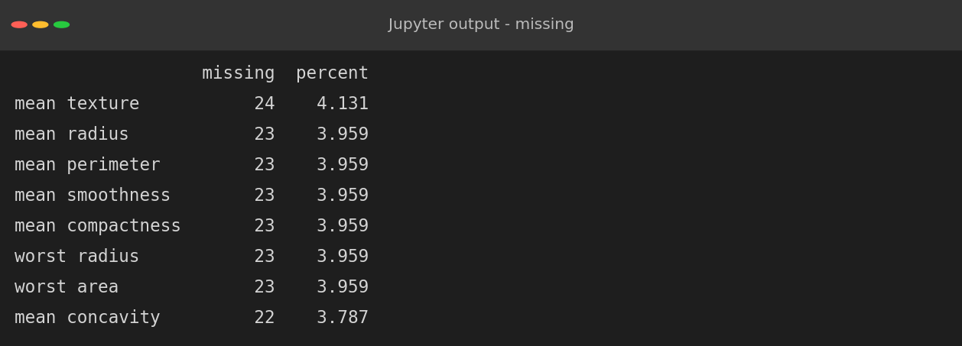
Figure 5: Missing values per column
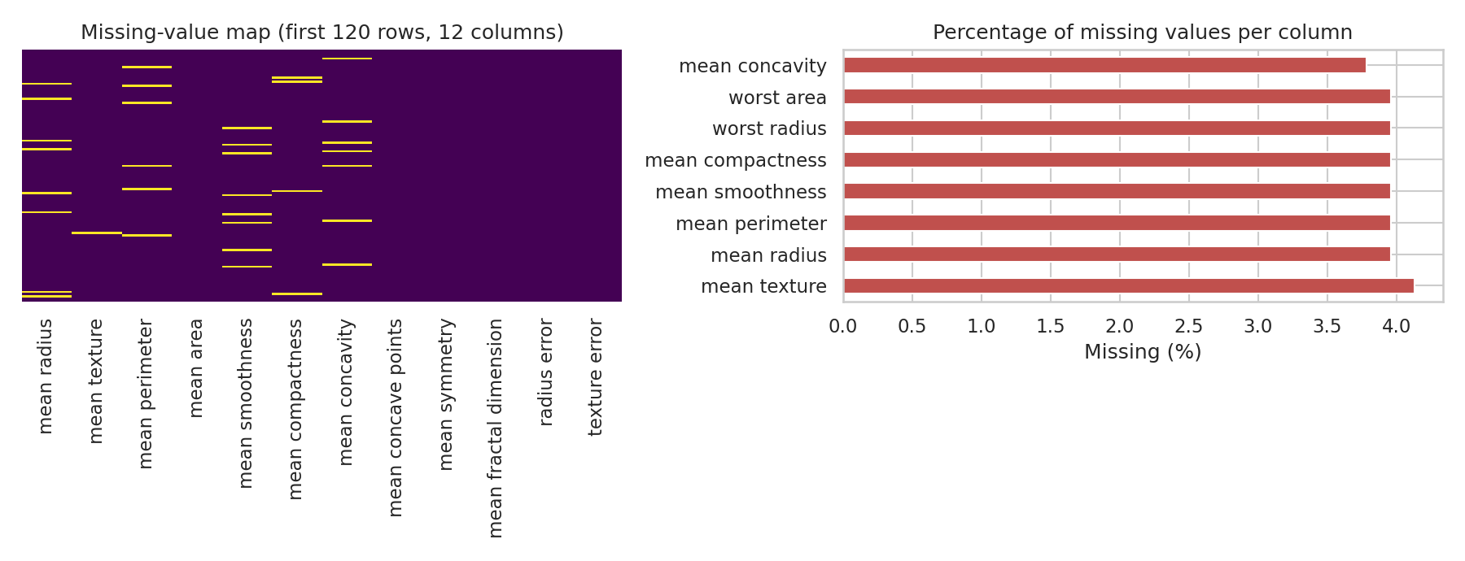
Figure 6: Missing-value map (left) and percentage missing per column (right)
Eight columns contain between 3.8% and 4.1% missing cells. The missing-value map shows horizontal yellow dashes scattered at random with no vertical stripe or block pattern, which suggests the values are missing completely at random (MCAR). This is the most benign mechanism: it means imputing values will not introduce a systematic bias, and the choice of method can be made on accuracy alone.

6. Fixing Data Types, Labels and Duplicates
Code 7: Converting data types, standardising labels and dropping duplicates
df = raw.copy()
df["mean fractal dimension"] = pd.to_numeric(
df["mean fractal dimension"].replace("?", np.nan))
print("Dtype now:", df["mean fractal dimension"].dtype)
df["diagnosis"] = (df["diagnosis"].str.strip().str.lower()
.map({"malignant": "malignant", "m": "malignant",
"benign": "benign", "b": "benign"}))
print(df["diagnosis"].value_counts().to_string())
before = len(df)
df = df.drop_duplicates().reset_index(drop=True)
print(f"Duplicates removed: {before - len(df)} -> shape {df.shape}")

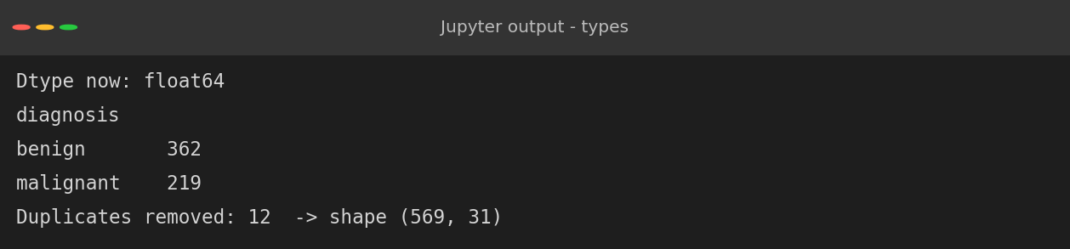
Figure 7: Cleaned data types, labels and duplicate removal
The fixes are simple but important:
- The '?' placeholders were converted to NaN and the column was cast to float, so they join the missing-value problem instead of hiding as text.
- The labels were stripped of white space, converted to lower case and mapped to two canonical values, 'malignant' and 'benign'. The class counts are now 362 and 219 including duplicates, which after de-duplication match the true 357 and 212.
- The 12 exact duplicates were dropped, restoring the original 569 rows.

7. Handling Erroneous Entries
Erroneous values are different from missing values and outliers: they are impossible or inconsistent, so they are treated as missing rather than kept. Two checks were applied.
- Range check: texture cannot be negative.
- Consistency check using geometry: area and radius are not independent. For a near-circular nucleus the area is approximately pi x radius squared. The ratio of the recorded area to this expected area should therefore be close to 1.
Code 8: Detecting negative values and geometric inconsistencies
neg = (df.drop(columns="diagnosis") < 0).sum()
print("Negative values per column:")
print(neg[neg > 0].to_string())
df.loc[df["mean texture"] < 0, "mean texture"] = np.nan
exp_area = np.pi * df["mean radius"] ** 2
ratio = df["mean area"] / exp_area
flag = ratio > 1.6
print("\nArea/(pi*r^2) ratio: median =", round(ratio.median(), 3))
print("Rows violating geometry rule:", int(flag.sum()))
print(df.loc[flag, ["mean radius", "mean area"]].round(1))
fig, ax = plt.subplots(1, 2, figsize=(12, 4.6))
ax[0].scatter(df["mean radius"], df["mean area"], s=14, c=np.where(flag, "red", "#4f81bd"))
ax[0].set_xlabel("mean radius"); ax[0].set_ylabel("mean area")
ax[0].set_title("Radius vs area (red = inconsistent entries)")
sns.boxplot(x=df["mean area"], ax=ax[1], color="#9bbb59")
ax[1].set_title("Boxplot of mean area before correction")
plt.tight_layout(); plt.savefig(f"{FIG}/w1_errors.png", dpi=150)
df.loc[flag, "mean area"] = np.nan

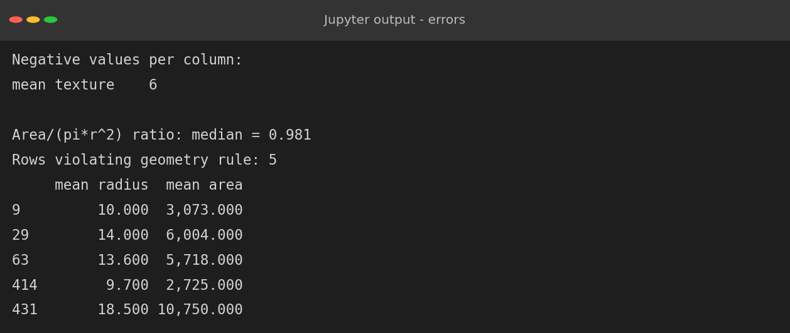
Figure 8: Detection of erroneous entries
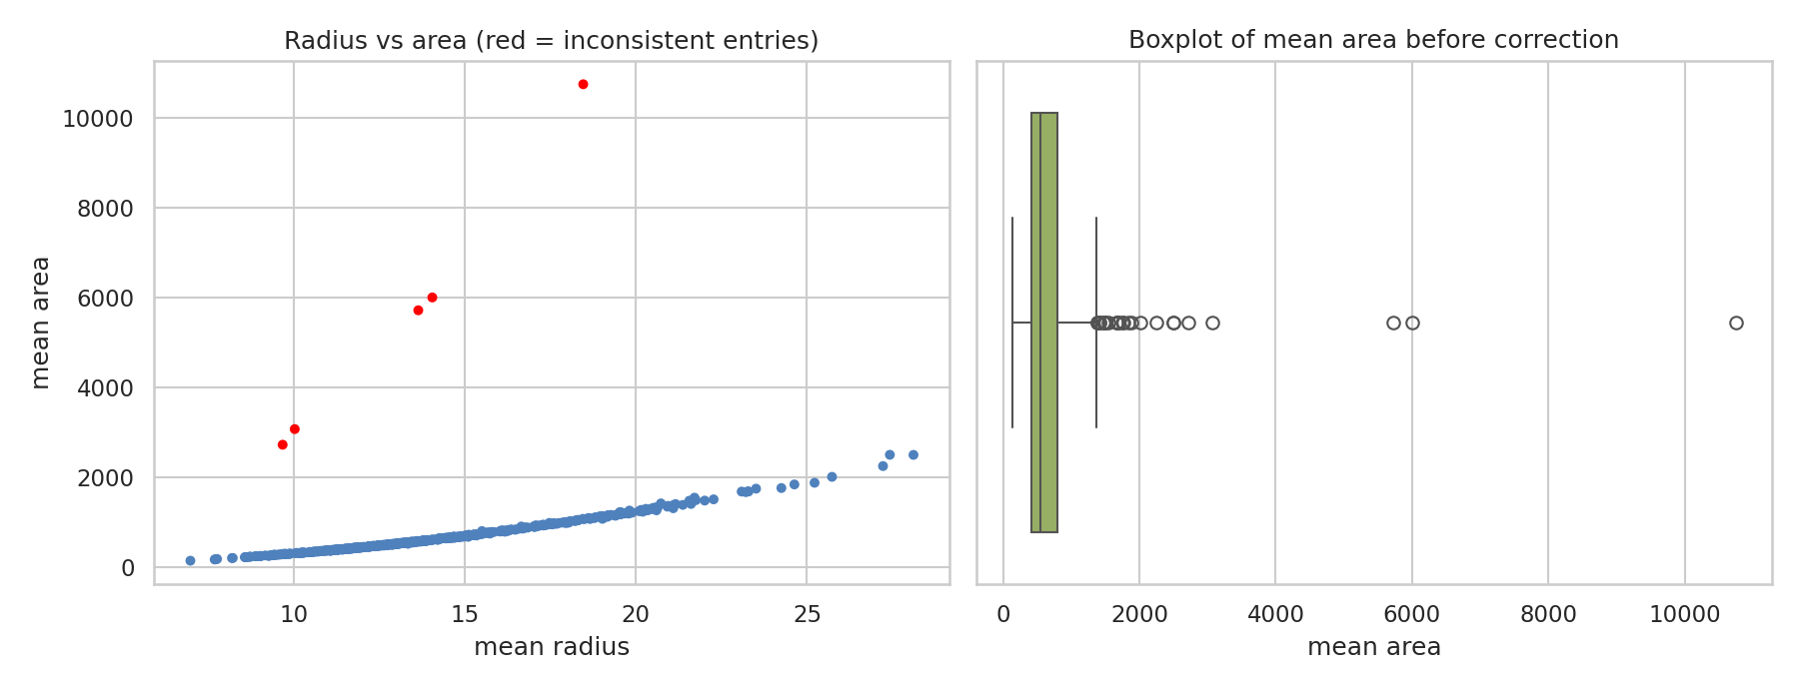
Figure 9: Radius versus area: five red points break the geometric relationship
The median ratio is 0.981, confirming that the geometric rule holds for the genuine data. Five rows have a ratio far above 1.6; for example a radius of 18.5 with an area of 10,750. These are exactly the five injected decimal errors. They are not extreme-but-real tumours, because a real tumour with a large radius would also show a proportionally large area. They were set to missing so that they can be re-estimated together with the other gaps. The six negative textures were treated the same way.
This step illustrates an important principle: domain knowledge can separate errors from genuine outliers in a way that purely statistical rules such as the IQR cannot.

8. Handling Missing Values
After the previous steps the dataset holds the original 4% gaps plus the cells that were invalidated as erroneous. Three common strategies were compared: mean imputation, median imputation and K-Nearest-Neighbours (KNN) imputation, which estimates a missing value from the five most similar complete rows.

8.1 Choosing the method with an experiment
Rather than choosing by habit, the methods were compared objectively. A complete subset of the data was taken, 10% of values in four columns were hidden, each method was asked to restore them, and the error was measured as a normalised RMSE (RMSE divided by the column standard deviation, so 1.0 means no better than guessing the average).
Code 9: Comparing imputation strategies
feat = [c for c in df.columns if c != "diagnosis"]
complete = df[feat].dropna()
mask_cols = ["mean radius", "mean texture", "mean concavity", "worst area"]
test = complete.copy()
true_vals, m = {}, {}
for c in mask_cols:
ix = RNG.choice(test.index, size=int(0.1 * len(test)), replace=False)
m[c] = ix; true_vals[c] = test.loc[ix, c].copy(); test.loc[ix, c] = np.nan
def nrmse(imp):
out = []
for c in mask_cols:
e = np.sqrt(((imp.loc[m[c], c] - true_vals[c]) ** 2).mean())
out.append(e / complete[c].std())
return np.mean(out)
mean_i = pd.DataFrame(SimpleImputer(strategy="mean").fit_transform(test), columns=feat, index=test.index)
med_i = pd.DataFrame(SimpleImputer(strategy="median").fit_transform(test), columns=feat, index=test.index)
sc = StandardScaler().fit(test)
knn_i = pd.DataFrame(sc.inverse_transform(KNNImputer(n_neighbors=5).fit_transform(sc.transform(test))), columns=feat, index=test.index)
res = pd.Series({"Mean": nrmse(mean_i), "Median": nrmse(med_i), "KNN (k=5)": nrmse(knn_i)})
print("Normalised RMSE of imputation (lower is better):")
print(res.round(3).to_string())
plt.figure(figsize=(6.5, 4))
res.plot.bar(color=["#4f81bd", "#9bbb59", "#c0504d"], rot=0)
plt.ylabel("Normalised RMSE"); plt.title("Imputation strategy comparison")
plt.tight_layout(); plt.savefig(f"{FIG}/w1_impute.png", dpi=150)

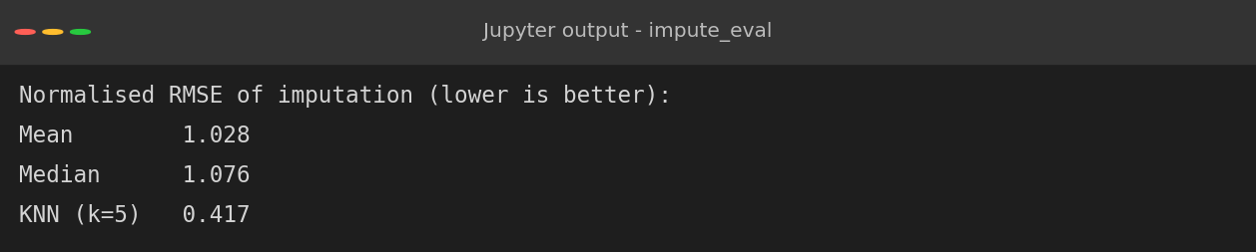
Figure 10: Normalised RMSE of imputation strategies
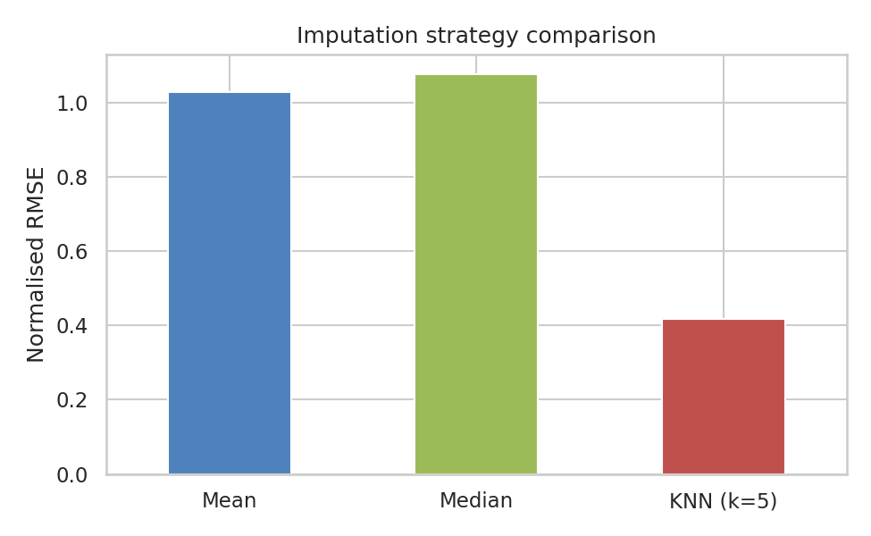
Figure 11: Comparison of imputation strategies
KNN imputation reduced the error to 0.417, compared with 1.028 for the mean and 1.076 for the median. The result is intuitive: the nuclear measurements are strongly correlated (radius, perimeter and area move together), so a row's neighbours carry real information about its missing values, whereas a column average ignores it entirely. KNN was therefore selected. Features were standardised before searching for neighbours so that large-scale columns such as area do not dominate the distance calculation.
Code 10: Final KNN imputation
sc = StandardScaler().fit(df[feat])
imputed = KNNImputer(n_neighbors=5).fit_transform(sc.transform(df[feat]))
clean = pd.DataFrame(sc.inverse_transform(imputed), columns=feat)
clean["diagnosis"] = df["diagnosis"].values
print("Missing values after imputation:", int(clean.isna().sum().sum()))
print("Rows x columns:", clean.shape)

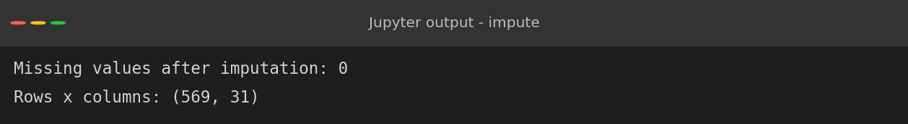
Figure 12: Dataset after imputation
All missing values were filled and the dataset has again 569 rows and 31 columns.

9. Outlier Analysis
With the errors removed, the remaining unusual values need to be judged carefully. Two standard detectors were used: the IQR rule (points beyond 1.5 x IQR from the quartiles) and the z-score rule (|z| > 3).
Code 11: Detecting outliers with IQR and z-scores
q1, q3 = clean[feat].quantile(0.25), clean[feat].quantile(0.75)
iqr = q3 - q1
cnt = ((clean[feat] < q1 - 1.5 * iqr) | (clean[feat] > q3 + 1.5 * iqr)).sum()
print("Top 8 columns by IQR-flagged values:")
print(cnt.sort_values(ascending=False).head(8).to_string())
z = (clean[feat] - clean[feat].mean()) / clean[feat].std()
print("\nRows with any |z| > 3 :", int((z.abs() > 3).any(axis=1).sum()))
cols5 = ["mean radius", "mean texture", "mean area", "worst area", "mean concavity"]
fig, ax = plt.subplots(1, 5, figsize=(14, 4))
for a, c in zip(ax, cols5):
sns.boxplot(y=clean[c], ax=a, color="#8064a2"); a.set_title(c, fontsize=10)
plt.suptitle("Boxplots after error correction: remaining points are genuine tumour variation")
plt.tight_layout(); plt.savefig(f"{FIG}/w1_outliers.png", dpi=150)

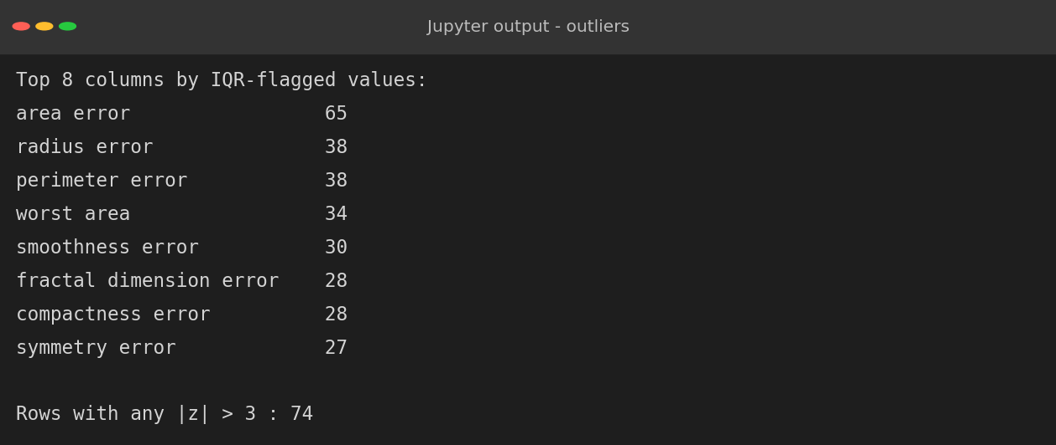
Figure 13: Outlier counts
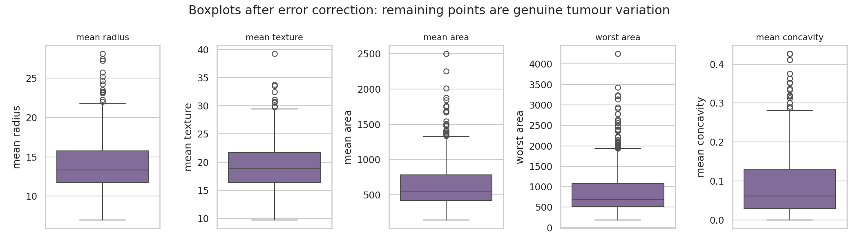
Figure 14: Boxplots of selected features after error correction
74 rows have at least one value with |z| > 3 and the 'area error' feature has 65 points beyond the IQR fences. The boxplots show a smooth, continuous right tail rather than isolated spikes. This is typical of biological size measurements: a minority of tumours are simply larger. Removing these rows would delete the most clinically important cases (large malignant masses) and shrink an already small dataset.
Decision: the remaining outliers are retained as genuine observations. Their influence is reduced through a log transformation and robust modelling choices instead of deletion. The report keeps this distinction explicit: errors are corrected, genuine extremes are kept but tamed.

10. Transformation and Feature Preparation

10.1 Reducing skewness
Code 12: Measuring skewness and applying a log transform
skew = clean[feat].skew().sort_values(ascending=False)
print("Most skewed features:")
print(skew.head(6).round(2).to_string())
hi = skew[skew > 1].index
proc = clean.copy()
proc[hi] = np.log1p(proc[hi])
print("\nLog-transformed columns:", len(hi))
print("Skew after (same top 6):")
print(proc[skew.head(6).index].skew().round(2).to_string())
fig, ax = plt.subplots(2, 2, figsize=(10, 6.5))
for j, c in enumerate(["mean area", "worst area"]):
sns.histplot(clean[c], kde=True, ax=ax[0, j], color="#c0504d")
ax[0, j].set_title(f"{c} (before, skew={clean[c].skew():.2f})")
sns.histplot(proc[c], kde=True, ax=ax[1, j], color="#4f81bd")
ax[1, j].set_title(f"{c} after log1p (skew={proc[c].skew():.2f})")
plt.tight_layout(); plt.savefig(f"{FIG}/w1_transform.png", dpi=150)

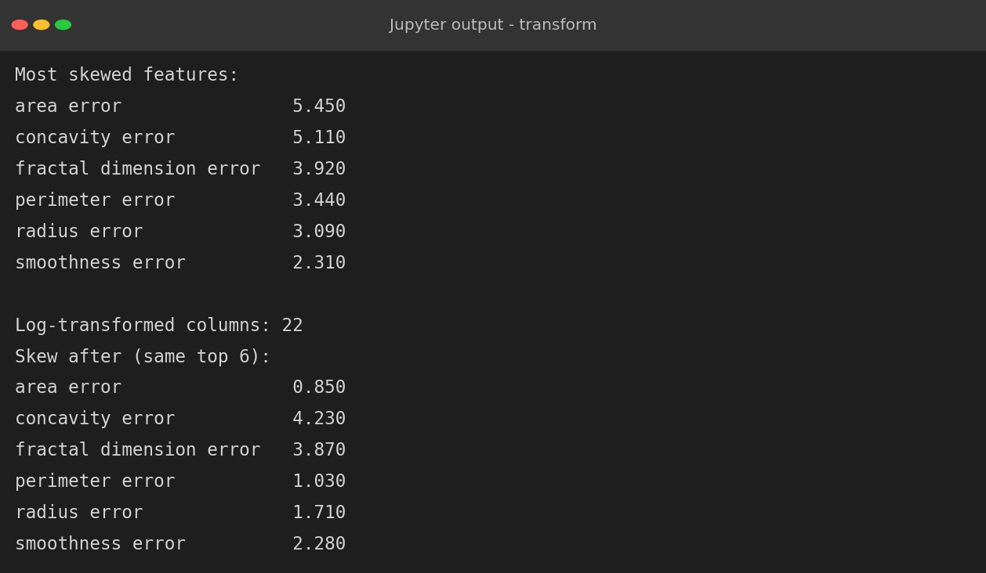
Figure 15: Skewness before and after the transformation
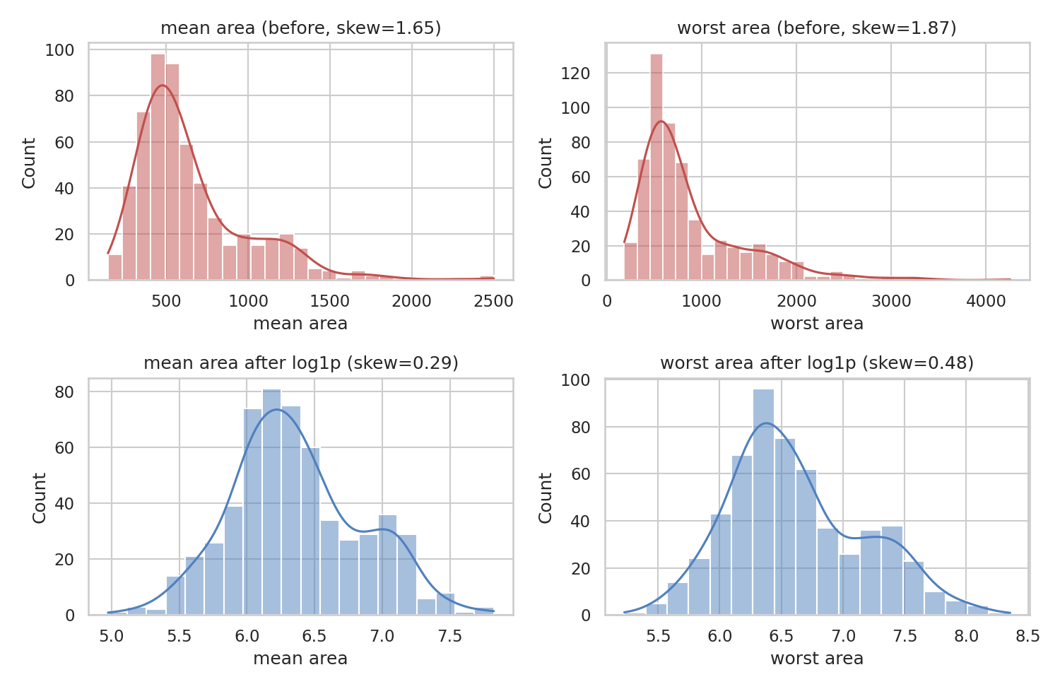
Figure 16: Distribution of area features before (top) and after (bottom) log1p transformation
22 features had skewness above 1. A log(1 + x) transformation reduced the skewness of mean area from 1.65 to 0.29, of worst area from 1.87 to 0.48 and of area error from 5.45 to 0.85, producing a much more symmetric shape that suits linear models and distance-based methods. The transformation was not equally effective for every column: 'concavity error' (4.23) and 'fractal dimension error' (3.87) remain strongly skewed because of their heavy tails. This is an honest limitation noted for later modelling stages, where tree-based models can handle such features without transformation.

10.2 Encoding and redundancy
Code 13: Encoding the target and checking multicollinearity
final = proc.copy()
final["target"] = final["diagnosis"].map({"malignant": 1, "benign": 0})
final = final.drop(columns="diagnosis")
corr = final[feat].corr().abs()
upper = corr.where(np.triu(np.ones(corr.shape), k=1).astype(bool))
drop_hc = [c for c in upper.columns if (upper[c] > 0.95).any()]
print("Highly correlated (>0.95) features flagged:", len(drop_hc))
print(drop_hc)
plt.figure(figsize=(8.5, 7))
sns.heatmap(final[feat[:10]].corr(), cmap="coolwarm", center=0, annot=True,
fmt=".2f", annot_kws={"size": 6}, cbar_kws={"shrink": .8})
plt.title("Correlation of mean-value features (cleaned data)")
plt.tight_layout(); plt.savefig(f"{FIG}/w1_corr.png", dpi=150)
final.to_csv("out/week1_cleaned_dataset.csv", index=False)
print("Saved cleaned dataset:", final.shape)

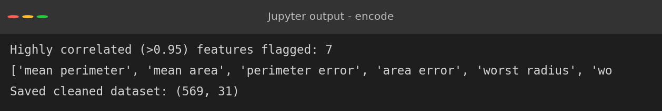
Figure 17: Target encoding and correlated features
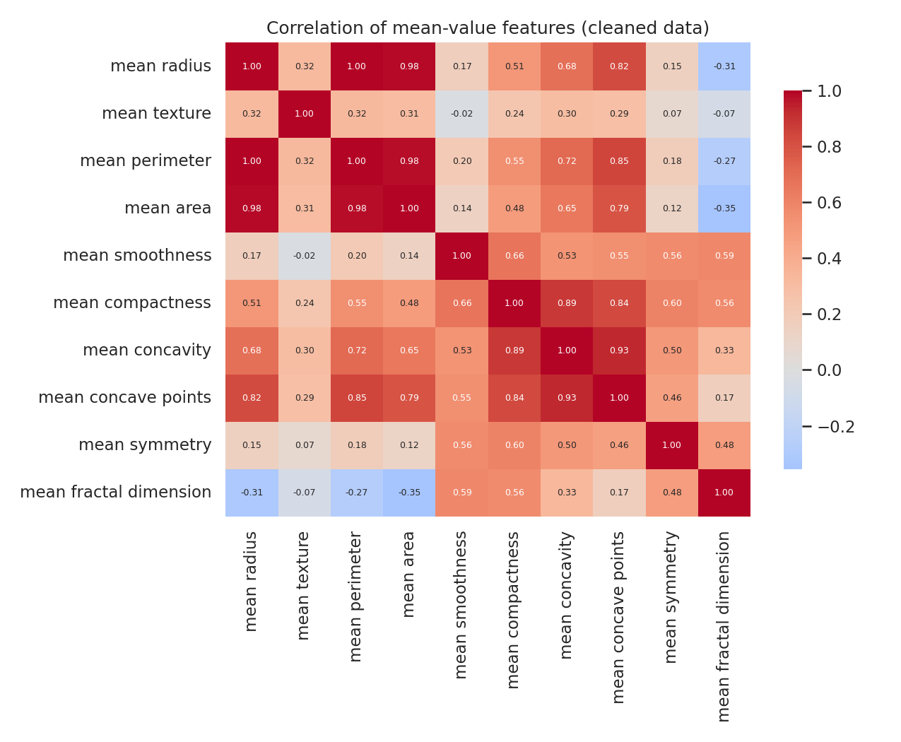
Figure 18: Correlation heatmap of the mean-value features
The diagnosis was encoded as 1 for malignant and 0 for benign. Seven features are correlated above 0.95 with another feature, mainly the radius, perimeter and area families. They were flagged rather than dropped, because whether to remove them depends on the model: regularised models and tree ensembles tolerate redundancy, while plain linear regression does not. The cleaned dataset was saved as week1_cleaned_dataset.csv.

11. Validation of the Cleaned Dataset
A cleaning process must be verified, not just executed. Two checks were run. First, structural: no missing values, no duplicates and no negative values remain. Second, because the true original values are known, the cleaned column means were compared with the truth.
Code 14: Final quality checks against the ground truth
chk = pd.DataFrame({"missing": final.isna().sum().sum(),
"duplicates": final.duplicated().sum(),
"negatives": int((final[feat] < 0).sum().sum()),
"rows": len(final), "cols": final.shape[1]}, index=["cleaned"])
print(chk.T.to_string(header=False))
# compare cleaned (before log) means with the true original means
chk2 = pd.DataFrame({"true mean": original[feat[:5]].mean(),
"cleaned mean": clean[feat[:5]].mean()})
chk2["abs % diff"] = (chk2["cleaned mean"] / chk2["true mean"] - 1).abs() * 100
print()
print(chk2.round(3))

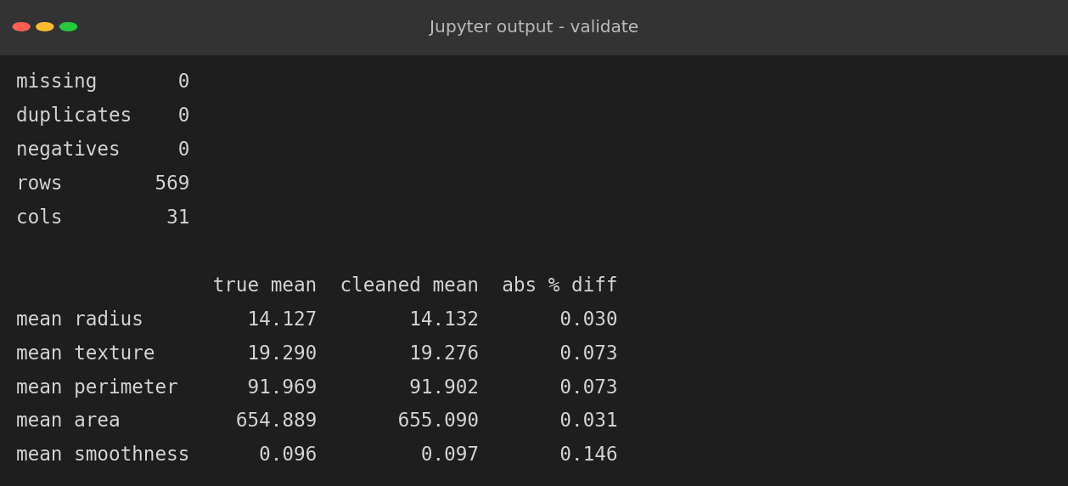
Figure 19: Validation results
All structural checks pass. The mean of every inspected feature is within 0.15% of its true value, which shows that the corrections and imputation restored the data distribution almost exactly instead of distorting it.

12. Challenges Faced and How They Were Overcome
Table 3: Summary of challenges and solutions
Challenge | How it was overcome
A clean source dataset gave nothing to clean | Controlled, seeded defects were injected into a copy, and the original was kept as ground truth for objective validation.
Impossible values hidden among valid ones | Range checks and a geometric consistency rule (area compared with pi x radius squared) were applied instead of relying on statistics alone.
Deciding which outliers are errors | Domain reasoning separated genuine large tumours from entry errors; only the latter were corrected.
Choosing an imputation method | A masking experiment measured each method's error; KNN reduced it by roughly 60%.
Text labels in many spellings | Whitespace stripping, lower-casing and an explicit mapping dictionary, followed by a value count to confirm two classes.
Features on very different scales | Standardisation before KNN imputation so that distances are not dominated by area.
Skewed features not fully fixed by log transform | Documented the limitation and left the choice of model-specific handling to later stages.

13. Impact of Preprocessing on Subsequent Analyses
To show that cleaning matters rather than merely asserting it, the same classifier (logistic regression) was evaluated with five-fold cross-validation on two versions of the data: a naive version that simply drops every row containing a missing value and uses features as they are, and the cleaned and scaled version produced in this report.
Code 15: Comparing a naive pipeline with the cleaned pipeline
Xr = raw.drop(columns="diagnosis").apply(pd.to_numeric, errors="coerce")
yr = raw["diagnosis"].str.strip().str.lower().str[0].map({"m": 1, "b": 0})
naive = Xr.assign(y=yr).dropna() # naive: drop rows with NaN
cv = StratifiedKFold(5, shuffle=True, random_state=0)
lr = LogisticRegression(max_iter=5000)
s_naive = cross_val_score(lr, naive.drop(columns="y"), naive["y"], cv=cv)
s_clean = cross_val_score(make_pipeline(StandardScaler(), LogisticRegression(max_iter=5000)),
final[feat], final["target"], cv=cv)
s_naive_sc = cross_val_score(make_pipeline(StandardScaler(), LogisticRegression(max_iter=5000)),
naive.drop(columns="y"), naive["y"], cv=cv)
impact = pd.DataFrame({"rows used": [len(naive), len(final)],
"CV accuracy": [s_naive.mean(), s_clean.mean()]},
index=["Naive (drop NaN, no scaling)", "Cleaned pipeline"])
print(impact.round(4))
print("Naive rows with scaling only:", len(naive), "acc", round(s_naive_sc.mean(), 4))
plt.figure(figsize=(6.5, 4))
plt.bar(["Naive", "Cleaned"], impact["CV accuracy"], color=["#c0504d", "#4f81bd"])
plt.ylim(0.85, 1.0); plt.ylabel("5-fold CV accuracy")
plt.title("Effect of preprocessing on a logistic regression")
for i, v in enumerate(impact["CV accuracy"]): plt.text(i, v + .002, f"{v:.3f}", ha="center")
plt.tight_layout(); plt.savefig(f"{FIG}/w1_impact.png", dpi=150)

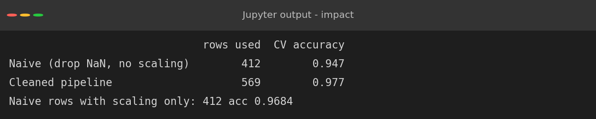
Figure 20: Effect of preprocessing on model accuracy
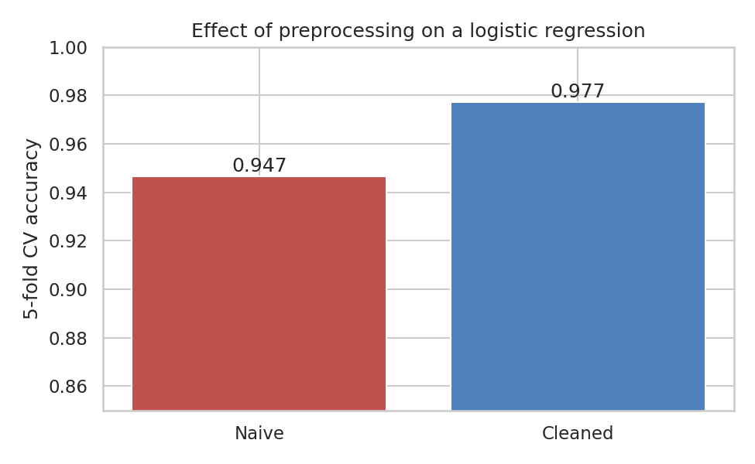
Figure 21: Cross-validated accuracy of a naive pipeline versus the cleaned pipeline
The naive approach keeps only 412 of the 569 patients, losing about 28% of the data, and reaches 94.7% accuracy. The cleaned pipeline keeps all 569 patients and reaches 97.7%. Adding scaling alone to the naive data already raises accuracy to 96.8%, so part of the improvement comes from scaling and part from retaining more rows. The comparison is also a reminder to stay measured: with a dataset this easy the absolute gain is a few percentage points, but the cost of the naive approach, discarding over a quarter of the patients, would be far more serious on a harder problem.
Other consequences of the choices made here:
- Statistics: unrepaired decimal errors inflate the mean area from about 655 to about 700 and its standard deviation from about 352 to about 638 (an 80% increase), which would mislead any hypothesis test.
- Distance-based methods (KNN, clustering) are dominated by area and perimeter unless the data is scaled.
- Imputation can leak information if done on the full dataset before a train-test split. For the modelling weeks, imputers and scalers must be fitted on training data only, inside a pipeline.
- Log transformation changes the interpretation of coefficients: effects become multiplicative rather than additive.

14. Conclusion
The raw dataset contained text in a numeric column, ten spellings of two labels, 12 duplicate rows, 184 empty cells, six impossible negative values and five decimal-place errors. Each problem was detected with an explicit check, treated with a justified method and verified against the ground truth. The final dataset has 569 rows and 31 columns, with no missing, duplicated or impossible values, and its feature means agree with the true data to within 0.15%.
The main lessons are that exploration must come before cleaning, that domain knowledge is often the best error detector, that imputation methods should be chosen by experiment, and that outliers should be investigated rather than automatically removed. The cleaned file will be reused in the supervised learning task.

15. References
- Street, W. N., Wolberg, W. H. and Mangasarian, O. L. (1993). Nuclear feature extraction for breast tumor diagnosis. IS&T/SPIE International Symposium on Electronic Imaging.
- Dua, D. and Graff, C. UCI Machine Learning Repository: Breast Cancer Wisconsin (Diagnostic). University of California, Irvine.
- Pedregosa, F. et al. (2011). Scikit-learn: Machine Learning in Python. Journal of Machine Learning Research, 12.
- McKinney, W. (2010). Data structures for statistical computing in Python. Proceedings of the 9th Python in Science Conference.

